
Pythagoras Investigation 2018
Name:______________________
Validation
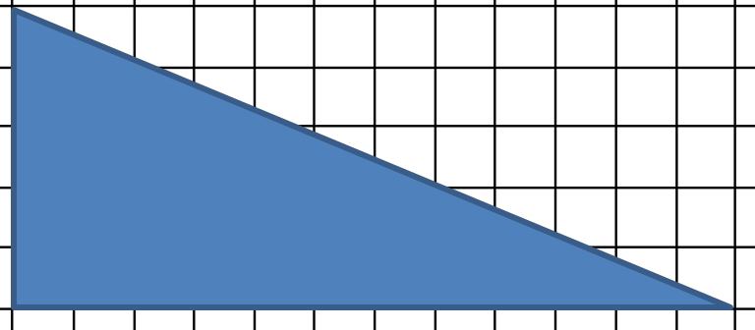
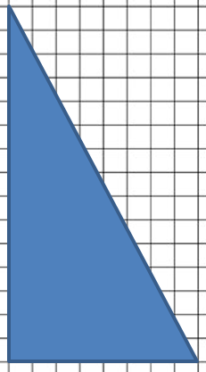
/ 31 marks]

Triangle 1

Triangle 2

[6 marks]
Question 1.
On the 2 triangles above, label the hypotenuse with the letter “c” and the other 2 sides with “a” and “b”.

[6 marks]
Question 2.
For each of the 2 triangles above, measure the lengths of the sides and record those measurements in the table below.

Triangle | Side a | Side b | Side c
1
2

Question 3
[8 marks]
For both triangles complete the table below

Triangle | Area of square made from side a =  $a×a=$a² | Area of square made from side b =  $b×b=$b² | a² + b² | Area of square made from side c =  $c×c=$c²
1
2

Question 4.
[3 marks]
Write equation linking a², b² and c²?

______ ______ = _________
[2 marks]
Question 5.
If you were told that a right angled triangle gave you a value of a² + b² equal to 9;
- What would the value of c² be?

- Can you now work out the length of side “c”? If so what would it be?

[2 marks]
Question 6
In a right angled triangle, a² = 49 and b² = 576
- What is the value of c².

- what is the length of side c?

[2 marks]
Question 7
In a right angled triangle, side a = 12 cm and side b = 9cm.
- What is the value of c².

- what is the length of side c?

[2 marks]
Question 8.
If you were told that c² = 169 and that b² = 144;
- What would the value of a² be?

- Can you work out the length of side “a”? If so what is it?

End of Investigation

